To follow the Documentation by each and every step: <https://www.vultr.com/docs/how-to-install-haproxy-on-ubuntu-20-04/?utm_source=performance-max-apac&utm_medium=paidmedia&obility_id=16876059738&utm_adgroup=&utm_campaign=&utm_term=&utm_content=&gclid=Cj0KCQiAzeSdBhC4ARIsACj36uG-APcWsfDn-mftFvCe8Lw5JgZHnOL6aTARmt5IRA21wN33X9DHqyAaAuONEALw_wcB>

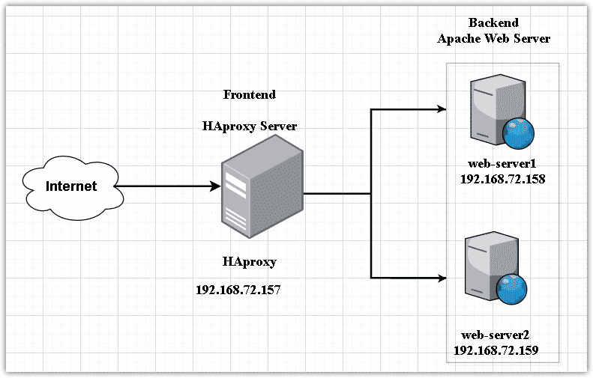

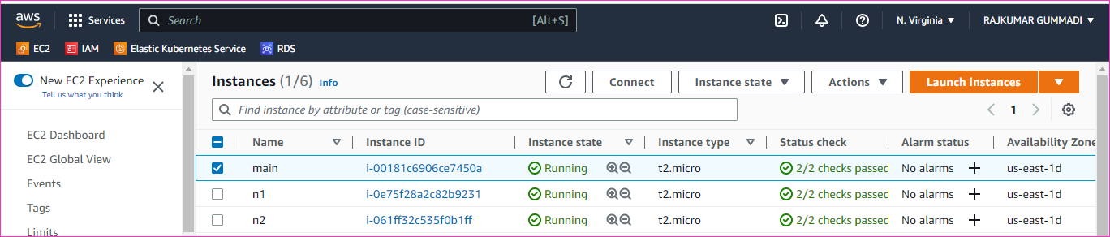

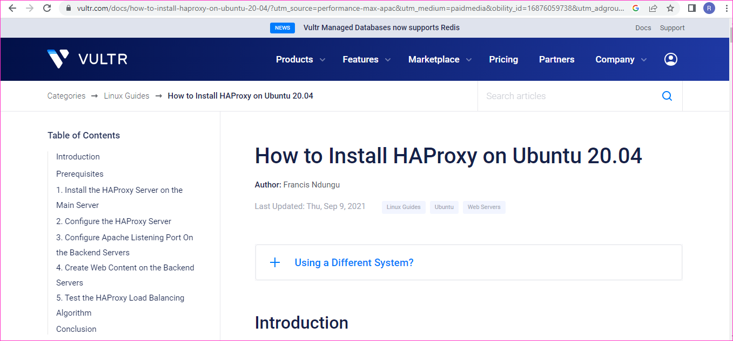

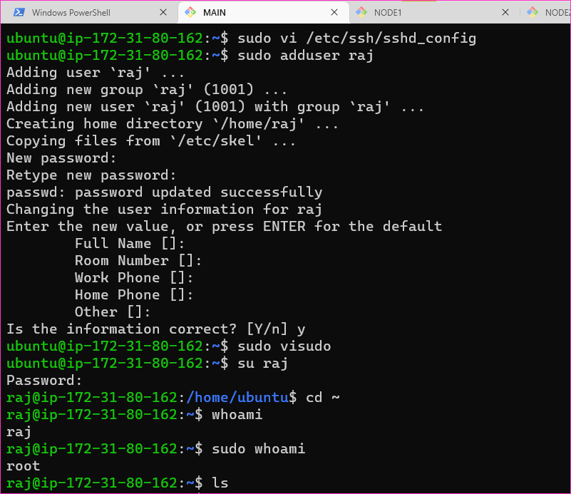

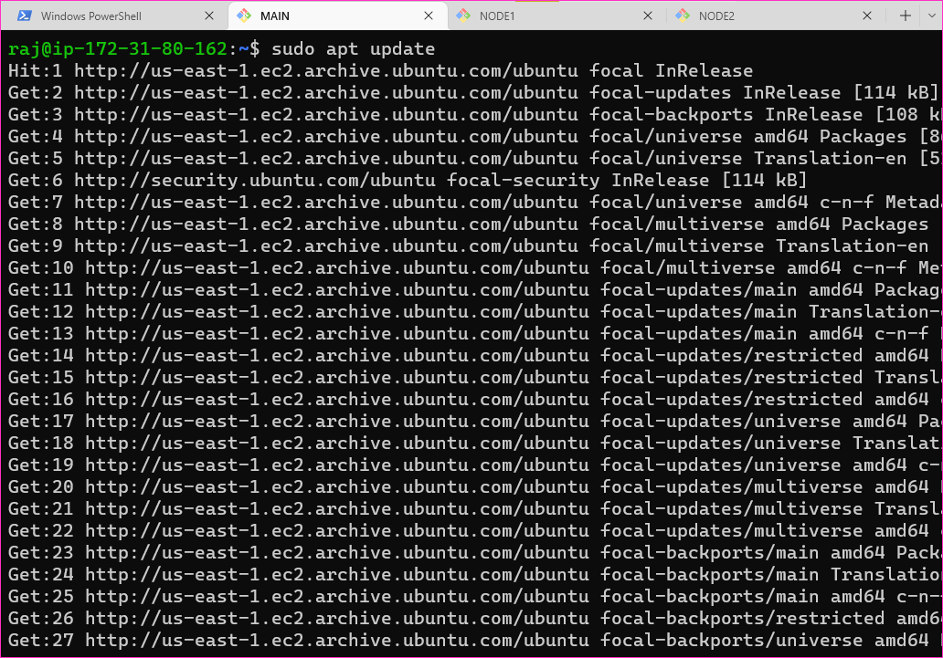

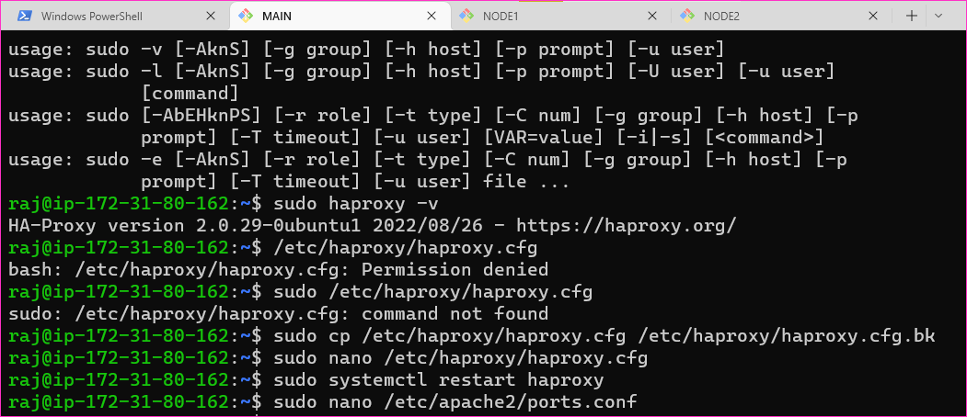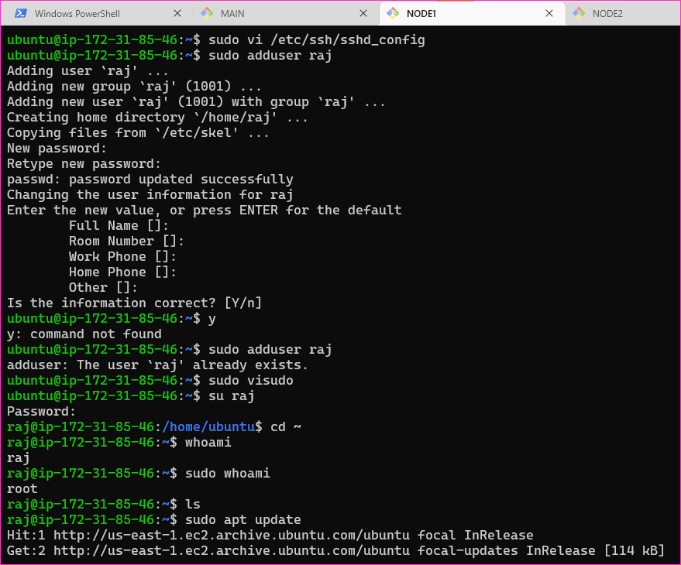

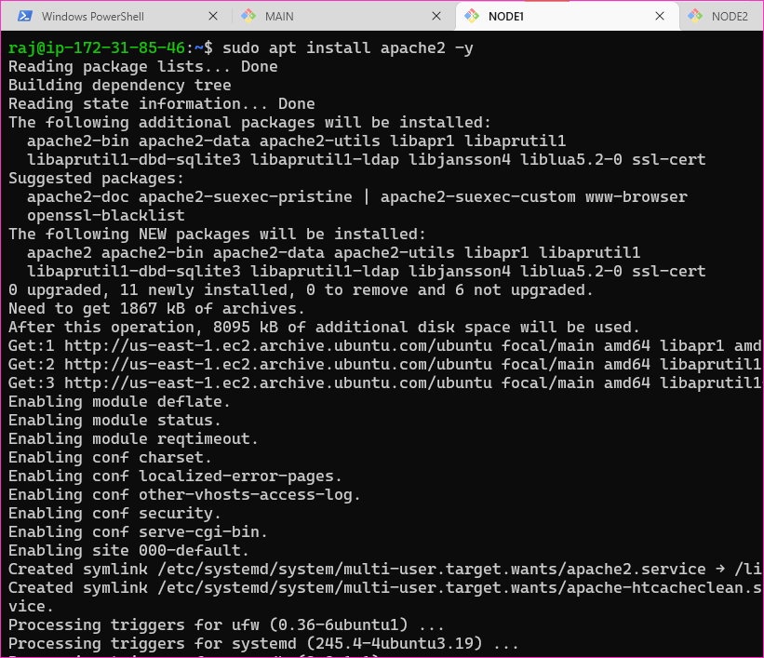

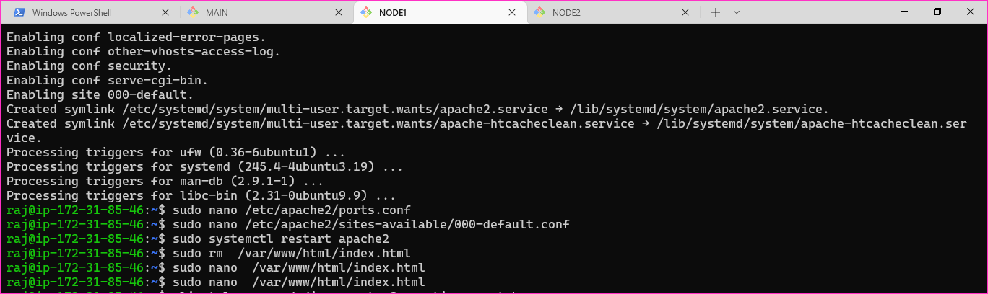

Same prcess in node2

* Browser: http://<public ipaddr of main>

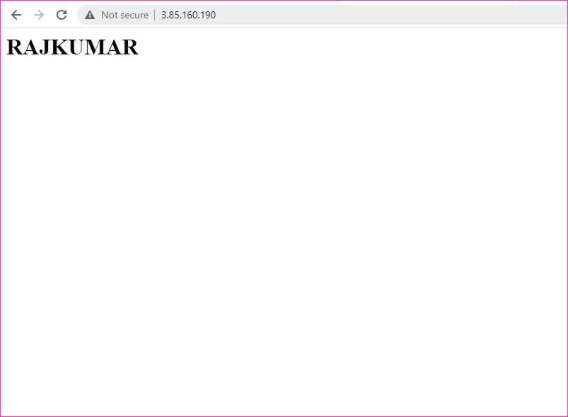

And then refresh it



* http://<public ipaddr of main>:32600

